Hamlin Mat Madness Youth Wrestling Tournament
Sunday, January 12, 2020
Hamlin Education Center
Weigh In: 10:00-12:00
Start Time: 1pm
Divisions: 6 & under through 11-12
Trophies for 1st Medals for 2nd, 3rd, 4th
Wrestlers will be grouped with approx. 4 to a group
Based on age and weight
Three 1 ½ minute periods
$10/ wrestler
$5/adult
$2/student
Pre-school & under/free

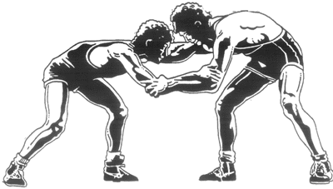

Concessions available
Questions?? Contact Rod St. Pierre 605-868-2961

Address:44577 188th Street Hayti, SD 57241
(From Hayti: 4 miles west on 188th St; From SD Hwy 28: 5 miles north on 446th Ave;
From SD Hwy 22: 7 miles south on 446th Ave)

